Notes

* + To ensure that packets are sent and received correctly, the internet uses a variety of protocols, including the Internet Protocol (IP) and the Transmission Control Protocol (TCP). IP is responsible for routing packets to their correct destination, while TCP ensures that packets are transmitted reliably and in the correct order.
  + **Packet:** A small unit of data that is transmitted over the internet.
  + **Router:** A device that directs packets of data between different networks.
  + **IP Address:** A unique identifier assigned to each device on a network, used to route data to the correct destination. (4 numbers found dot between them 192.168.1.1)
  + **Domain Name:** A human-readable name that is used to identify a website, such as google.com.
  + **DNS:** The Domain Name System is responsible for translating domain names into IP addresses.
  + **HTTP:** The Hypertext Transfer Protocol is used to transfer data between a client (such as a web browser) and a server (such as a website).
  + **HTTPS:** An encrypted version of HTTP that is used to provide secure communication between a client and server.
  + **SSL/TLS:** The Secure Sockets Layer and Transport Layer Security protocols are used to provide secure communication over the internet.
  + الدومين نيم ده اسم للويب سايت ذى جوجل دوت كوم بييجى بقى بروتوكول اسمه دى ان اس بيحول الاسم ل اى بي عباره عن ارقام وكل ده علشان يسهل عمليه البحث عن الموقع للانسان
  + IP is responsible for routing packets of data to their correct destination, while TCP and UDP ensure that packets are transmitted reliably and efficiently. DNS is used to translate domain names into IP addresses, and HTTP is used to transfer data between clients and servers.
  + HTTP is the protocol used to transfer data between a client (such as a web browser) and a server (such as a website). When you visit a website, your web browser sends an HTTP request to the server, asking for the webpage or other resource you've requested. The server then sends an HTTP response back to the client, containing the requested data.
  + HTTPS is a more secure version of HTTP, which encrypts the data being transmitted between the client and server using SSL/TLS (Secure Sockets Layer/Transport Layer Security) encryption. This provides an additional layer of security, helping to protect sensitive information such as login credentials, payment information, and other personal data.
  + When you visit a website that uses HTTPS, your web browser will display a padlock icon in the address bar, indicating that the connection is secure. You may also see the letters "https" at the beginning of the website address, rather than "http".

Chapter 1 (introduction to Networks)

1. What`s network, LAN, Common Network Components, VLAN, WAN, VPNs, Types of networks by Geographical Area, Network Architecture,
2. LAN (Local Area Network) -> Bus , Ring , Star
   1. [Your Recording 20.wav](https://fcihelwanedu-my.sharepoint.com/personal/amira_20210185_fci_helwan_edu_eg/Documents/Transcribed%20Files/Your%20Recording%2020.wav)
   2. 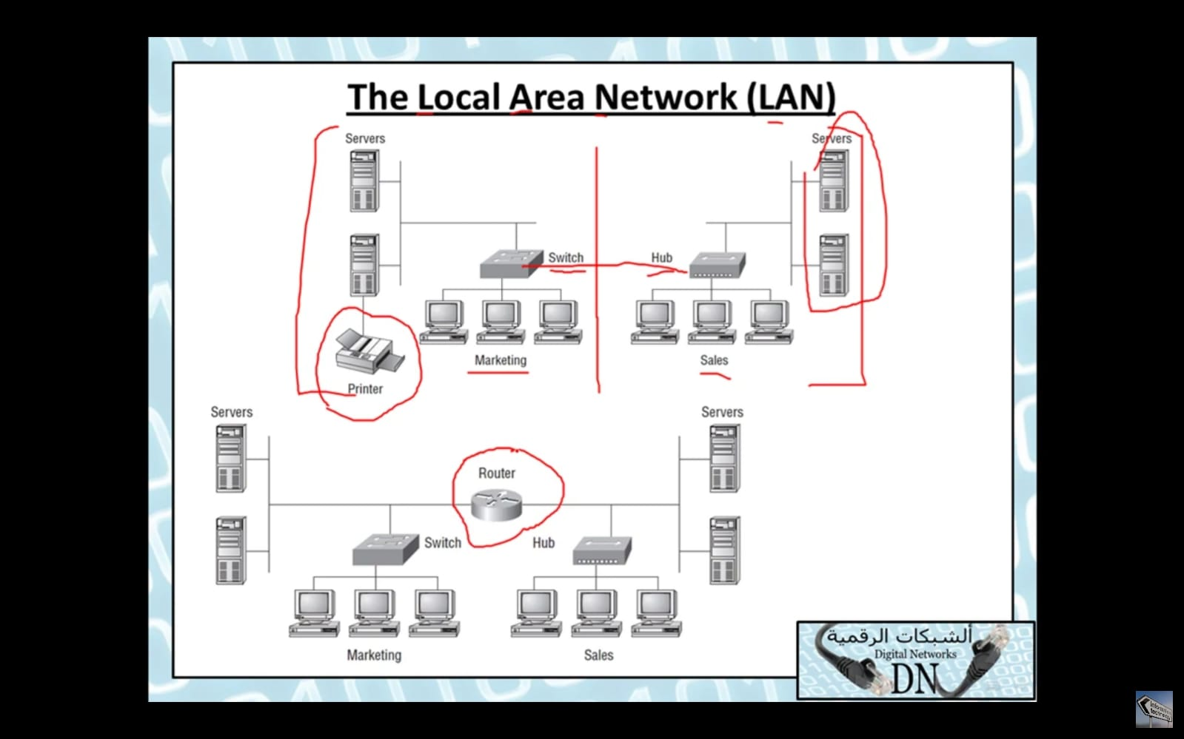
3. Common Network Components
   1. [Your Recording 21.wav](https://fcihelwanedu-my.sharepoint.com/personal/amira_20210185_fci_helwan_edu_eg/Documents/Transcribed%20Files/Your%20Recording%2021.wav)
   2. 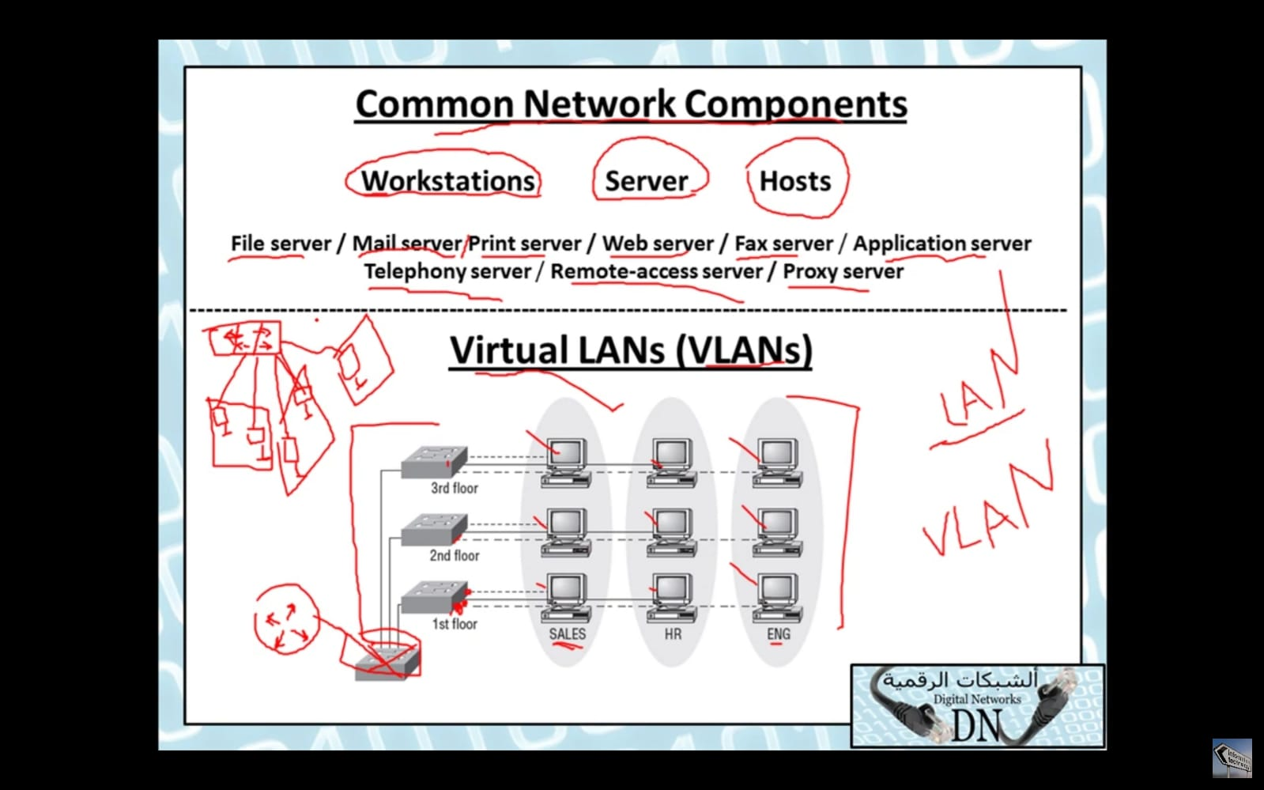
4. VLAN (Virtual LAN)
   1. [Your Recording 22.wav](https://fcihelwanedu-my.sharepoint.com/personal/amira_20210185_fci_helwan_edu_eg/Documents/Transcribed%20Files/Your%20Recording%2022.wav)
5. WAN (Wide Area Network)
   1. [Your Recording 23.wav](https://fcihelwanedu-my.sharepoint.com/personal/amira_20210185_fci_helwan_edu_eg/Documents/Transcribed%20Files/Your%20Recording%2023.wav)
6. VPNs (Virtual Private Networks)
   1. [Your Recording 24.wav](https://fcihelwanedu-my.sharepoint.com/personal/amira_20210185_fci_helwan_edu_eg/Documents/Transcribed%20Files/Your%20Recording%2024.wav)
7. Types of networks by Geographical Area
   1. [Your Recording 25.wav](https://fcihelwanedu-my.sharepoint.com/personal/amira_20210185_fci_helwan_edu_eg/Documents/Transcribed%20Files/Your%20Recording%2025.wav)
   2. 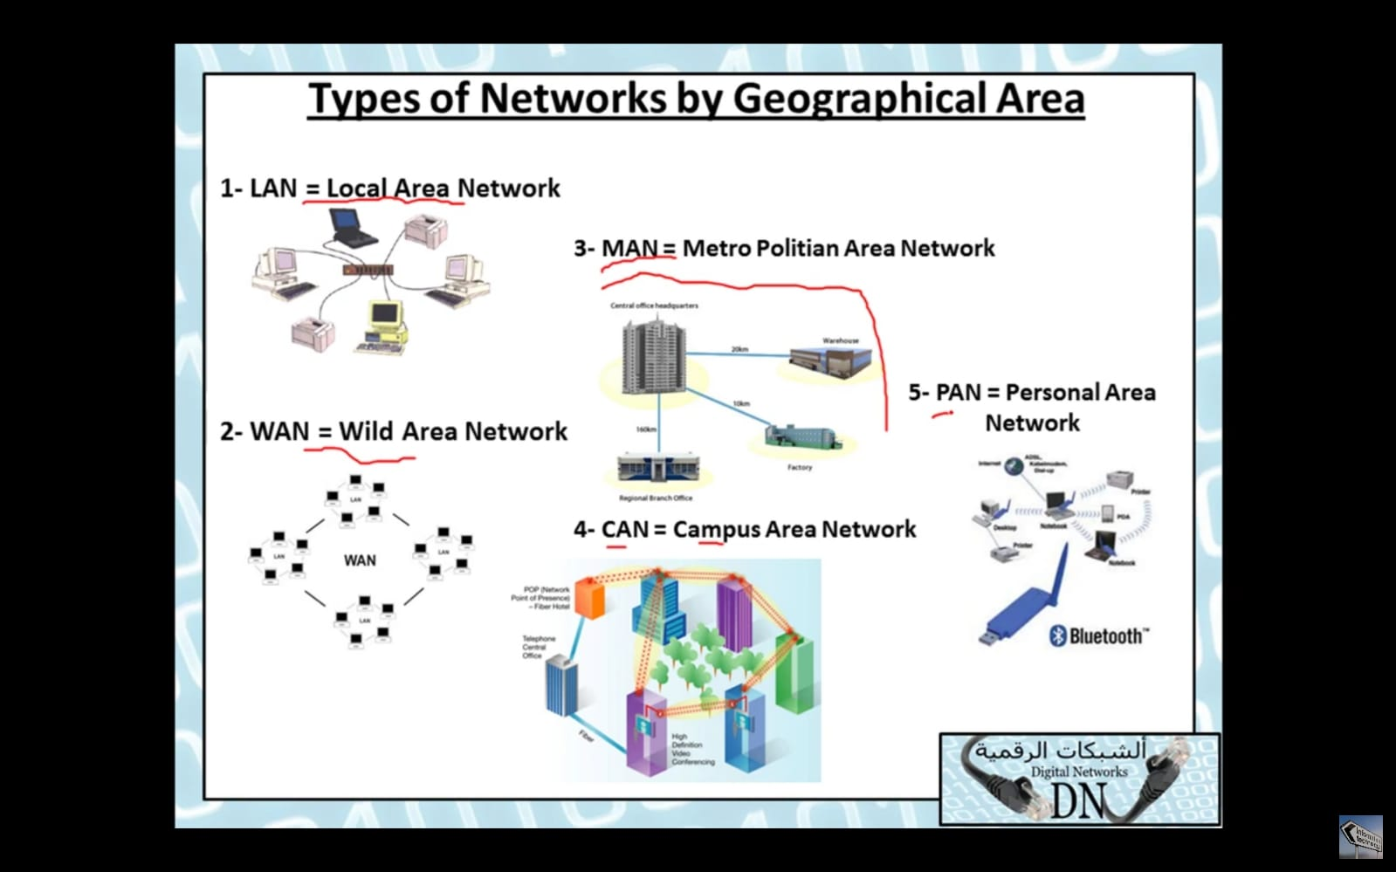
8. Network Architecture
   1. Peer to peer
      1. (كل جهاز بيبقى لوحده ولو عايزه اعدل يبقى هعدل فى كل واحد لوحده)
      2. (لازم ميزدش عن 10 اجهزه)
   2. Client/server Network
      1. (بيكون ليهم سيرفير مسئول عن ادارة الشبكه)
9. Physical Network topology
   1. Bus Topology

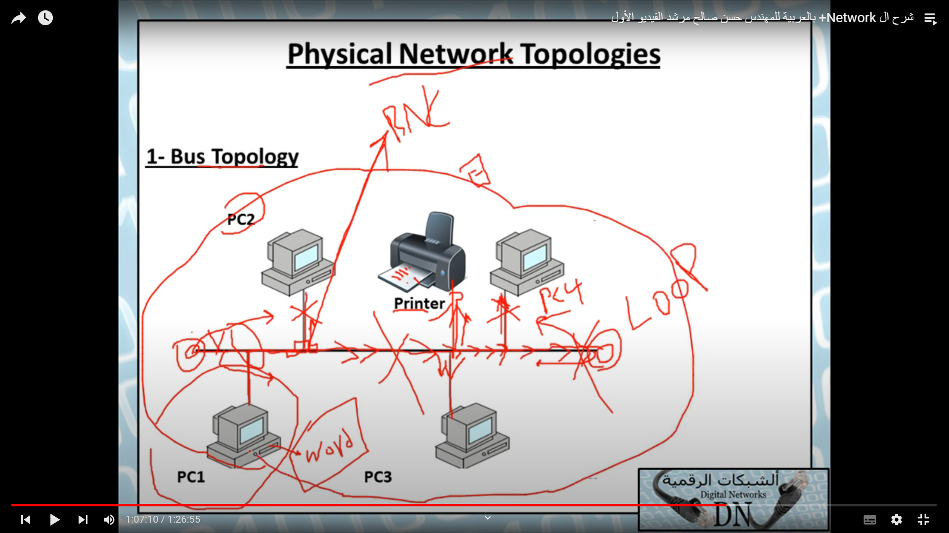

* + 1. Terminator -> damage signal to overcome loop problem
    2. It has a backbone
    3. Every device has a BNC Connector
       1. Cheap
       2. Slow
       3. Easy to install

[Bus Topology.wav](https://fcihelwanedu-my.sharepoint.com/personal/amira_20210185_fci_helwan_edu_eg/Documents/Transcribed%20Files/Your%20Recording%2027.wav)

* 1. Start topology

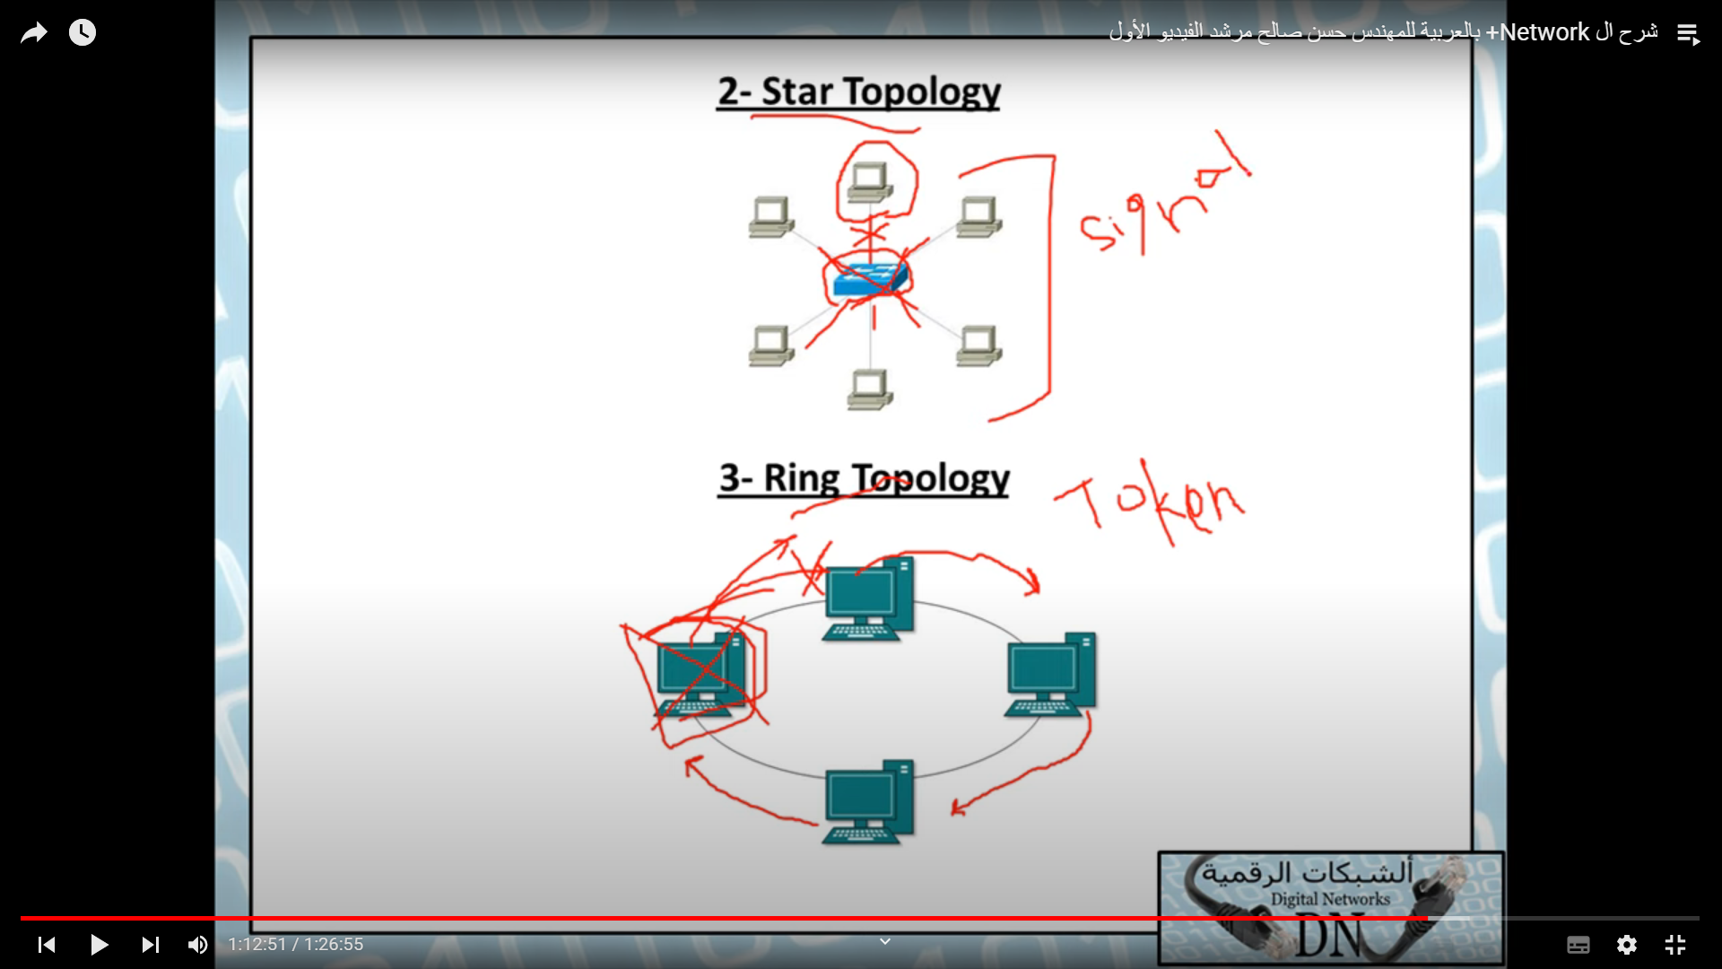

* + 1. It has a central device
    2. Dis & Con
       1. Easy to install

[Star Topology.wav](https://fcihelwanedu-my.sharepoint.com/personal/amira_20210185_fci_helwan_edu_eg/Documents/Transcribed%20Files/Your%20Recording%2028.wav)

* 1. Ring topology
     1. Signals called token
     2. CON & DIS
        1. If increased devices between sender & receiver will increase the time

[Ring Topology.wav](https://fcihelwanedu-my.sharepoint.com/personal/amira_20210185_fci_helwan_edu_eg/Documents/Transcribed%20Files/Your%20Recording%2029.wav)

* 1. Mesh -> least of collision

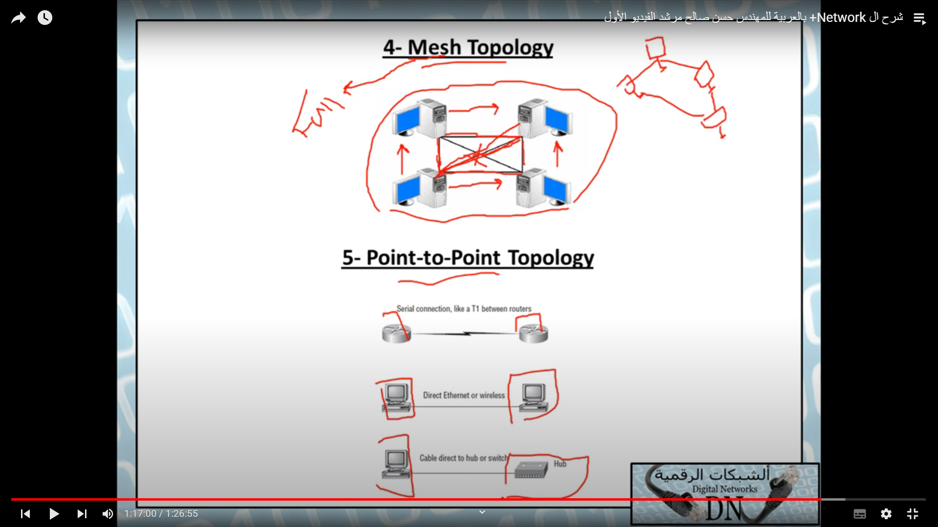

* + 1. Full mesh topology
    2. Con & Dis
       1. Security
       2. Most used on WAN

# [Mesh Topology.wav](https://fcihelwanedu-my.sharepoint.com/personal/amira_20210185_fci_helwan_edu_eg/Documents/Transcribed%20Files/Your%20Recording%2030.wav)

* 1. Point to point
     1. A device connects to another device directly
  2. Point to multipoint topology

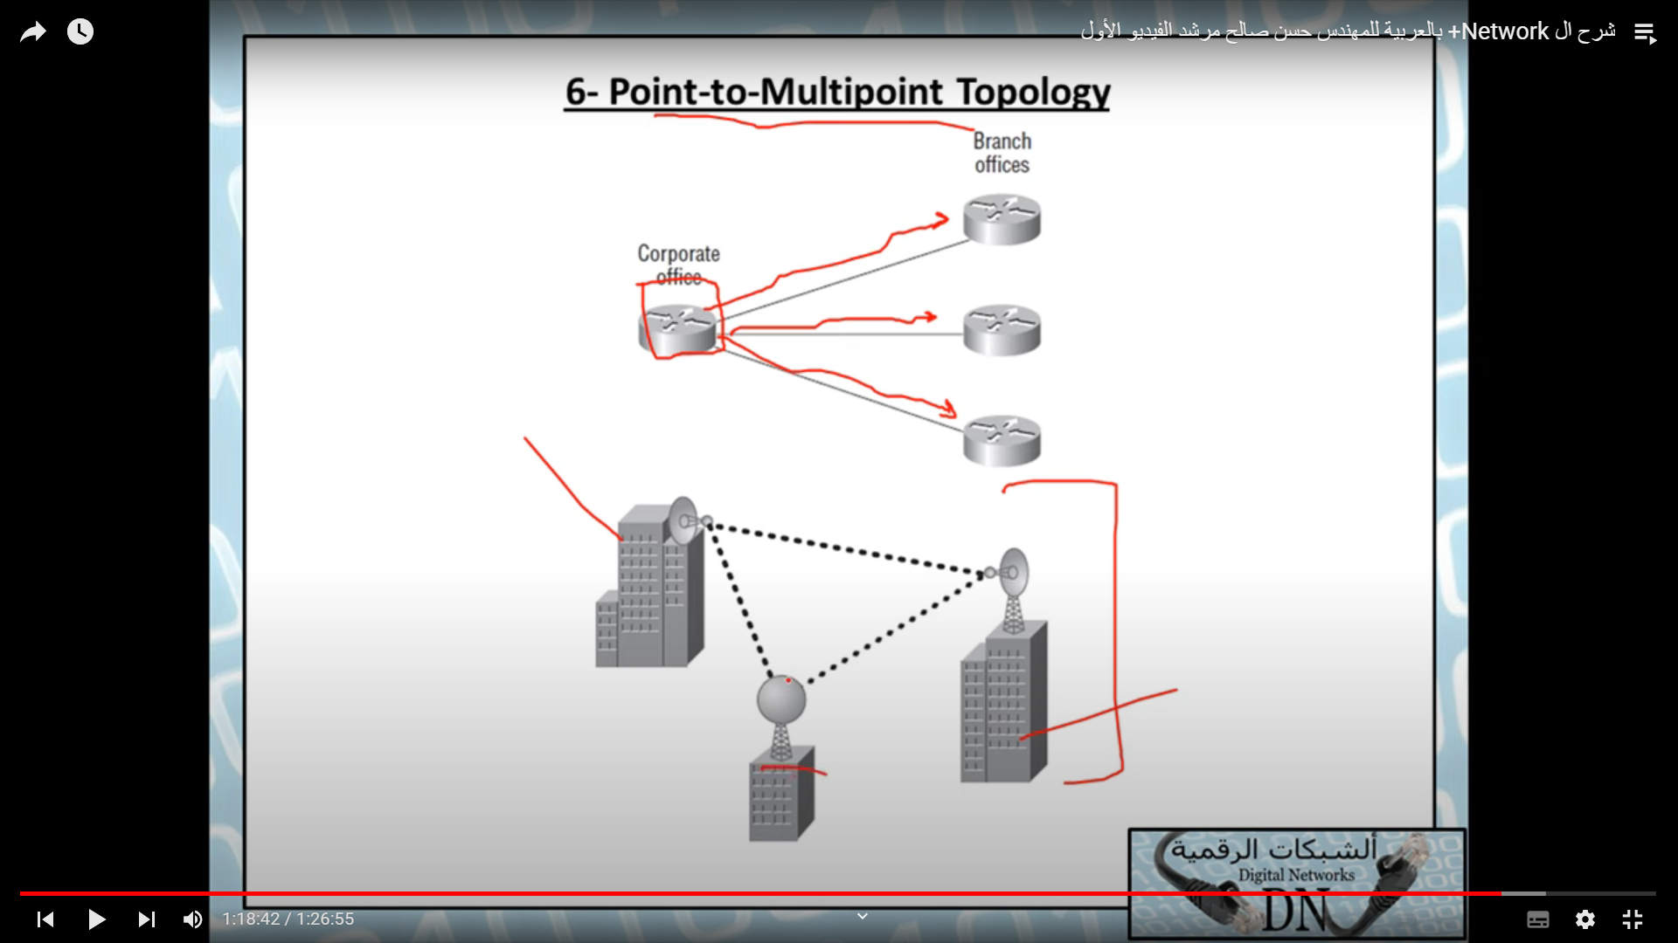

* + 1. Most used
  1. Hybrid topology
     1. A network that contains more than one topology
     2. Bus + star
     3. Star -> because it contains hub (main of bus topology)

1. Selecting the right topology
   1. Cost
   2. ease of installation
   3. ease of Maintenace
   4. fault-tolerance requirement

-----------------------------------------------------------------------------

Chapter 2

Chapter 3

Chapter 4

Chapter 5

Chapter 6

Chapter 7

Chapter 8

Chapter 9

Chapter 10

Chapter 12

Chapter 13

Chapter 14

Chapter 15

Chapter 16

Chapter 17

Chapter 18

Chapter 19

Chapter 20